**IFRS Landing Page**

1. **IFRS Course**

**Diploma in IFRS** is developed and offered by the leading professional accounting organization ACCA. This course offers the latest International Accounting Standards as issued by **International Accounting Standards Board(IASB)**. Auditors and professional accountants with three years or more of work experience can stay relevant in accounting space by gaining most updated knowledge through this short-duration IFRS program. One could complete this course in 3- 6 months by giving just one exam. Several lucrative jobs are available to a holder of this qualification.

Knowledge of IFRS is essential for those aspiring a career in accounting as it forms the

base for preparation of financial statements, internationally

**Download Brochure – Enquire Now Form**

1. **Why IFRS – Give it in Icon form**
2. International accounting framework
3. Accounting standards and principles
4. Set by the International Accounting Standard Board (IASB)
5. Enable uniform reporting
6. Most countries are converging or adopting their standards towards IFRS
7. 27,000 listed companies on 88 major stock exchanges use IFRS
8. Learn the local reporting requirements in India - Ind AS and IGAAP
9. Can be completed in 3-6 months
10. **Who is it for?**
11. Chartered Accountants, Company Secretaries, ICMA, and other finance professionals
12. Semi Qualified CA, CS, ICMA working in accounting domain
13. Finance managers, Financial controllers, and accountants
14. Private Equity and M&A professionals
15. MBA finance working in accounting domain
16. Students who want to begin a career in financial reporting

**Eligibility:**

1. If you are a professional accountant or auditor who works in practice or business, and are the member of IFAC membership body then you are eligible to take this ACCA financial reporting qualification.
2. If you are working in practice but not yet qualified & if you are not an IFAC member then also you are eligible but you will need to prove that you have one of the following:

a) Two years' relevant accounting experience and a relevant degree (attracting at least ACCA qualification exemptions for the Applied Knowledge and Corporate and Business Law (LW) exams)

b) Two years‘ relevant accounting experience and an ACCA Certificate in International Financial Reporting

c) Three years' relevant accounting experience

d) ACCA affiliate status

**4) Benefits of Studying IFRS / Advantages**

1. **Built your own Consultancy Firm -** Trained and professional IFRS experts can establish their consultancies to help companies migrate to IFRS.
2. **Multiple Profiles:** Various IFRS profiles are being offered in several sectors of the industry that include ITES, software, pharmaceutical, auto spare part, professional advisory companies, auditing firms, banking industry, Insurance industry, KPOs, etc.
3. **Work Globally -** Apart from India, 100+ countries have received permission to implement IFRS standards. Therefore, by being IFRS qualified, you are eligible to apply and work in these 100+ countries.
4. **Increasing Professional Demand:** Continuous amendments in these standards by regulators is creating need for IFRS Professionals with thorough understanding of these standards.
5. **IFRS Training Process:**

IFRS Registration > IFRS Training Classes > Mock Exams > Exam booking > Get Diploma in IFRS

**(You can make it in blocks or any other format which can show the process format)**

1. **Syllabus – Can be taken from our brochure**

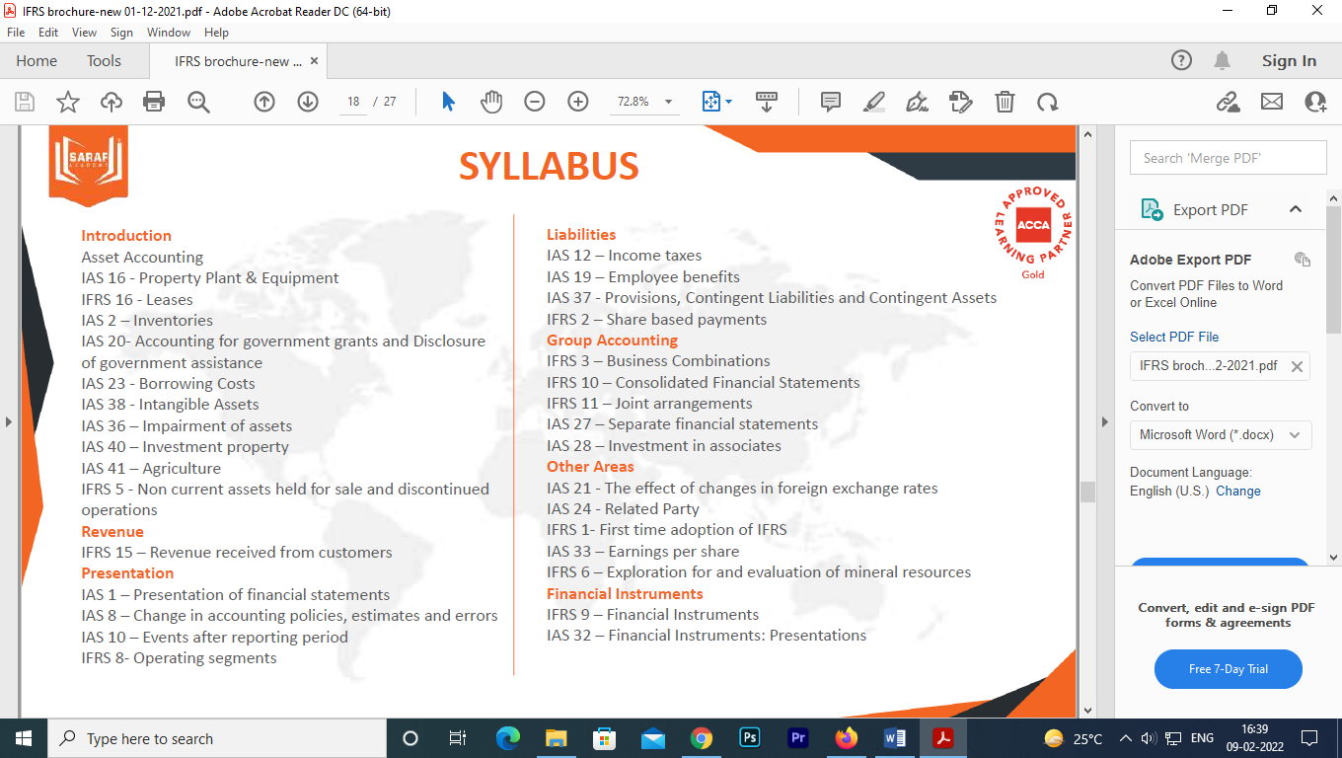

1. **Exam Pattern –**

* Number of Exams – One Exam
* Exams When – June/December beginning
* Exam Duration: 3 hrs
* Exam Centers: Across the Globe
* Pass Percentage: 50%

1. **What we will provide - Give it in Icon form**

* Free IFRS Registration – worth 89 GBP
* 120 hours Training Classes - LIVE and Recorded
* Get Trained by Industry experts
* Study Resources – In-house Notes & Presentations
* Mock Tests

1. **Why Us – same**
2. **Top Companies hiring our students**
3. **Testimonials –**
4. **Kapil Kakra -** Prakash sir being a great guide. After completion of his lecture, there are no doubts as all possible doubts are answered by sir himself
5. **Madhuvanthi S -** Value for money. The classes were very flexible and Prakash sir explains each and every aspect very clear. They provide full guidance on how to face exams and come out with flying colours.
6. **Mehul Ghelani -** Prakash Sir himself is an Institution, so we can call Saraf Academy as an Institution's coaching Institute. His efforts towards all the students can be felt only if you're in the class to feel it and difficult to describe in words. Academy support staff also imbibes same quality of efforts and are very helpful. I graciously thank Saraf Academy for their efforts in helping me clear the exam.
7. **Rajarshi Ray -** I am currently studying Dip IFRS and what I can vouch for is that Prakash Saraf sir is one of the best teacher you can get at an affordable cost. He is knowledgeable, humble and eager to help students in clearing their doubts.
8. **FAQs**
9. **What is IFRS?**

International Financial Reporting Standards (IFRS) are a set of accounting standards developed by the International Accounting Standards Board (IASB) that is becoming the global standard for the preparation of public company financial statements.

1. **What is the eligibility criteria for Diploma in IFRS?**

A candidate needs to be a commerce graduate at the minimum (with 3 years of work experience) or a professional like CA, CFA, MBA (with 3 years of work experience).

1. **Is it good to do a Diploma in IFRS offered by ACCA or ICWAI?**

IFRS certification course is quite important for you to obtain if you want to pursue a career in managing accounting standards. Both ACCA and ICWAI have their own significance. ACCA is the association that specializes basically in [IFRS](https://www.zelleducation.com/program/27/ifrs-course) and other accounting roles. ICWAI specialized in IND-AS, management accounting, and costing. Both have their own significance and are different from one another.

But as per the experts are concerned, the ACCA international finance reporting standards course is much more standardized based upon the demands of MNCs.

1. **What are the benefits of Diploma in IFRS?**

Here are few benefits which a Diploma holder in IFRS enjoys:

**Demand in industry:** IFRS qualified professionals are in high demand in MNCs and Big 4s which prefer people with international certifications. They are preferred across the globe because of their expertise in area of accounts.

**Career Development:** IFRS Diploma gives commitment to the professional for a successful career and highlight their potential for appropriate roles.

**Better salary package:** Many people consider salary package as potential criteria while choosing a career. IFRS Diploma gives you opportunity to earn more than a normal accountant by proving your expertise in the field of accounts.

1. **What is the expected salary for a Diploma in IFRS holder?**

Diploma in IFRS qualified professionals are offered salary of INR 5 to 6 lakhs per annum as per market survey.

1. **What benefits does a CA have with a diploma in IFRS?**

With a CA under your belt, DipIFR offers an additional qualification in accounting. This may increase your employability score marginally - but not by much.

More important is the fact that it gives a comprehensive exposure to IFRS, which is not there’s in the CA course currently.